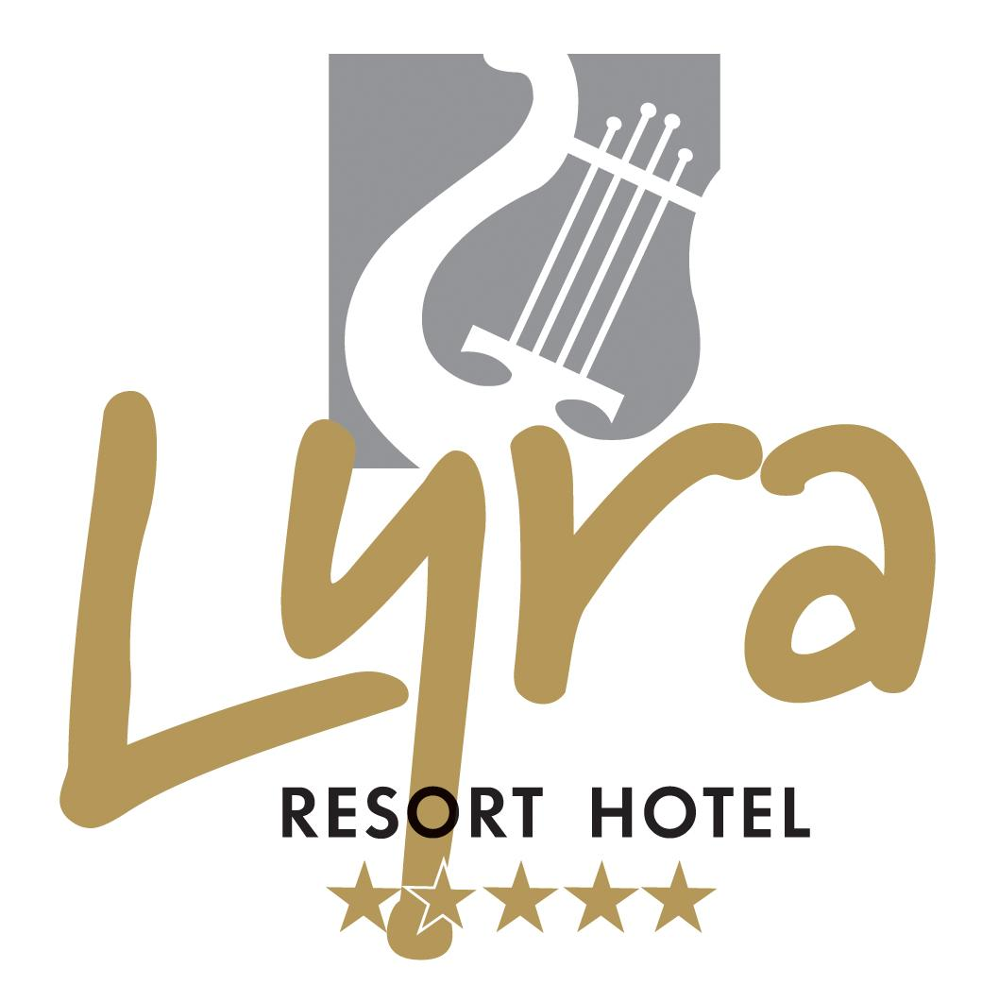
2011 SUMMER SEASON ALL INCLUSIVЕ CONSEPT
LYRA RESORT HOTEL 5*

Address : Kızılağaç Tourism Center Manavgat/ Antalya / TURKEY
Tel : +90 242 748 80 80
Fax : +90 242 748 78 90
e-mail : info@lyrahotel.com
Web : www.lyrahotel.com

Location : Our hotel is in Kızılağaç,coast to the sea,with 250 mt. long private beach. 75 km to Antalya Airport, 15 km to Side and 10 km to Manavgat. The hotel is situated on 30.000 m2 area, established as 5 floors with 948 beds (80 % with seaview) as main building and 17 double-floored villas in the garden which totally have 114 rooms with 328 beds.

Rooms
Facilities Free Of Charge

- 2 outdoor swimming pool
- 2 children pool
- 1 indoor pool (15.09.10- 31.03.11)
- 1 indoor children pool
- Aquapark (01.05.11-31.10.11)
- Hamam, sauna, vapour cabinet
- Fitness center
- 2 beachvolley
- Basketball
- Mini football ( 50 m x 25 m, nature grass)
( only for animation aktivities )
- Table tennis
- Tennis court (day time)
- Archery
- Dart
- Boccia
- Chess , backgammen
- Aerobic , gymnastic , water gym
- Step, streching
- Beach games
- Waterball
- Entertainment
- Cinema
- Disco
- Umbrella, deck chair, mattress, beach towels
- Wireless internet connection in lobby
- Baby carriage
- Baby telephone
- Climbing wall
- Mini golf
- 3 conference halls with equipment
- Stage
- Shuttlebus (01.05.11-31.10.11)

Facilities With Charge

- Import luxury alcoholic drinks
- Shopping center
- Massage, peeling
- Safe deposit boxes
- Telephone, fax
- Doctor
- Car rental
- Lightening for tennis court
- Billiards
- Laundry
- Internet
- Play station
- Pinball
- Skate
- Babysitting
- Water sports
- Diving school
- 24 hour room service
- Trampoline

- Bathtub and closet
- Hairdryer
- Central cooling system ( at 01.05. 2011 certain times ),split klimas in villas
- Satellite
- Safe deposit boxes
- Minibar ( coke, fanta, water, mineral water and beer free of charge )
- Telephone
- Balcony
- Laminant floor in main building, ceramic in villas
• Extra Bett ; Sofa + Box Bett

“ALL INCLUSIVE” CONSEPT:
Breakfast, late breakfast, lunch, dinner and late meal as open buffet, (01.05.11-31.10.11 A’la Carte restaurants, day long ; 7 outlets; gözleme house, pastry , simit , fruit , döner point , ice cream , cake time, chicken service, kumpir and turkish pizza and 2 snack buffets ) all local alcoholic / nonalcoholic drinks, beverages are included between 09:00 – 02:00 ( after 01.05.2011 in the Disco ).There is 1 main restaurant,
(01.05.11-31.10.11 1 children restaurant,4,disco bar, pool bar, beach bar, club pool bar) ,lobby bar 3 A’la Carte restaurants (by reservation ); Kebap, Lyra ve Italian A’la Carte .

Children Facilities

- Mini club (between 4-12 years)
- 2 playing ground
- Children restaurant 01.05.11-20.10.11
- Babysitting
- Baby carriage
- Lunapark 01.05.11-20.10.11
- Aquapark 01.05.11-20.10.11
- Trampoline 01.05.11-20.10.11

HOTEL INFORMATION

HOTEL NAME : LYRA RESORT HOTEL

CLASS : RESORT HOTEL

CATEGORY : 5 STAR

ADDRESS : KIZILAĞAÇ TOURISM CENTER

MANAVGAT / ANTALYA / TURKEY

TELEPHONE : +90 242 748 80 80 (pbx)

TELEFAX : +90 242 748 78 90

WEB : www.lyrahotel.com

e-mail : info@lyrahotel.com

PRESIDENT BOARD OF DIRECTOR : ERCAN EREN

GENERAL MANAGER : FERİDUN ERGÜN feridun.ergun@lyrahotel.com

ASST. GENERAL MANAGER : İPEK ERGÜL ipek.ergul@lyrahotel.com

FRONT OFFICE MANAGER : FIRAT FİDAN foml@lyrahotel.com

CONSEPT : ALL INCLUSIVE

ESTABLISHED : JUNE 2005

OPENED BETWEEN : 12 MONTHS

LANGUAGES : GERMAN, ENGLISH, RUSSIAN,TURKISH

BEACH 01.05.10-20.10.10 : SAND – COAST TO THE SEA , BLUE FLAG CERTIFICATED

LOCATION

DISTANCE TO AIRPORT : ANTALYA AIRPORT 75 KM

DRIVING TIME : 60 MINUTES

DISTANCE TO CENTRUM : ANTALYA 80 KM
MANAVGAT 10 KM

DISTANCE TO CITY CENTER : ANTALYA 80 KM
MANAVGAT 10 KM
SİDE 15 KM
KIZILAĞAÇ 1 KM

DISTANCE TO HISTORICAL PLACES : PERGE 90 KM
TERMESSOS 110 KM
PHASELIS 170 KM
MYRA 230 KM
ASPENDOS 53 KM
SİDE 15 KM

CLOSEST HOSPITAL : MANAVGAT 10 KM

ABOUT BEACH (01.05.11-31.10.11) : DECK CHAIR, MATTRESS, UMBRELLA FREE OF CHARGE
SEA TOWELS ARE AVAILABLE WITH THE TOWEL CARD.
STAGE 15.05.2011

DESCRIPTION : ESTABLISHED ON 30.000 m2 AREA ,COAST TO THE SEA,1 MAIN BUILDING AND 17 CLUB VILLAS

NUMBER OF ROOMS : 286 HOTEL ROOMS
4 SUIT, 82 FAMILY ROOMS, 192 STANDART ROOMS, 3 DISABLE ROOMS ,5 ECONOMY ROOMS WITH NO BALCONY
114 CLUB ROOMS
42 CLUB FAMILY ROOMS, 72 CLUB STANDART ROOMS
TOTALLY 400 ROOMS
NUMBER OF BEDS : 948

ROUTE

LOCAL TRANSPORTATION AND TAXI (MANAVGAT, SİDE, ANTALYA, ALANYA)

HOTEL FACILITIES

SWIMMING POOLS : 2 INDOOR SWIMMING POOL 750 m2, WATER-SLIDE POOL 215 m2, 2 CHILDREN POOL 24 m2, 1 OUTDOOR POOL 215 m2, 1 OUTDOOR CHILDREN POOL 8 m2

CONFERENCE AND MEETING HALLS : CONFERENCE HALL 500 m2
MEETING HALL 1 90 m2
MEETING HALL 2 60 m2

SHOPPING FACILITIES : JEWELLERY, WATCH AND SILVER SHOP, SUPERMARKET AND GIFT SHOP
BOUTİQUE, BAG STORE, HOME TEXTILE STORE, HAIR DRESSER, DOCTOR, PHOTO SHOP AND CAR RENTAL, INTERNET CAFE. ALSO, THERE IS A SHUTTLE SERVICE TO LYRA PARK SHOPPING CENTER WHERE IS 800 MT AWAY AND HAS MORE THAN 60 INTERNATIONAL STORES.

FACILITIES CHARGED AND FREE OF CHARGE

FACILITIES WITH CHARGE : WATER SPORTS 01.05.11-31.10.11 , BANANA, RINGO, PARASAILING, WATER SKI,
JET-SKI, SAILING AND CATAMARAN,DIVING SCHOOL. WATER SPORTS BETWEEN
10:00 – 18:00 ALL WATER SPORT ACTIVITIES ARE WITH RESERVATION AND
DEPEND ON THE WEATHER FORECAST,TENNIS COURT LIGHTENING, MASSAGE,
PEELING, DOCTOR, CAR RENTAL,LAUNDRY, INTERNET, PLAY STATIONS, BILLIARDS,
PINBALL, TELEPHONE, FAX, SAFE, LUNAPARK, BABYSITTING.

FACILITIES FREE OF CHARGE : DAY AND NIGHT ENTERTAINMENT 01.05.11-31.10.11 ,GAMES, SHOWS, CINEMA,
AEROBİC, STRECHING, STEP, GYMNASTİC, WATER GYM, WATERBALL, TENNIS COURT (DAYTIME/HARD FLOOR), CLIMBING WALL, BEACH VOLLEYBALL, BASKETBALL, ARCHERY, BOCCIA, DART, CHESS, BACKGAMMEN, POOL GAMES, AQUAPARK, HAMAM, SAUNA, VAPOUR CABINET, FITNESS CENTER, DISCO, UMBRELLA, DECK CHAIR, MATTRESS, BEACH TOWELS ,BEACH GAMES, BABY CARRIAGE, MINI GOLF.

CHILDREN ACTIVITIES : MINI CLUB 4 – 12 YEARS 10:00 – 12:30 / 14:30 – 17:30
2 PLAYING GARDEN
LUNAPARK ………………………………………….
CHILDREN RESTAURANT ………………………………………..

POCKET CINEMA : FOR CHILDREN 14:00 MINI CLUB
FOR ADULTS 22:30 CINEMA HALL

MINI FOOTBALL AREA : 50 x 25 LARGE NATURE GRASS

MINI GOLF : NATURE GRASS

RESTAURANTS AND BARS

RESTAURANTS

MAIN RESTAURANT : 750 PAX
CHILDREN RESTAURANT : 150 PAX 01.05.11- 31.10.11
MAIN REST. OPEN BUFFET BREAKFAST : 07:00 – 10:00
MAIN REST. OPEN BUFFET LATE BREAKFAST : 10:00 – 10:30 01.05.11- 31.10.11
MAIN REST. OPEN BUFFET LUNCH : 12:30 – 14:00
MAIN REST. OPEN BUFFET DINNER : 19:00 – 21:00
MAIN REST. LATE MEAL : 23:00 – 00:00 01.05.11- 31.10.11

A’LA CARTE (01.05.11-31.10.11)

KEBAP RESTAURANT : 19:30 – 21:00
LYRA RESTAURANT : 19:00 – 21:00
ITALIAN RESTAURANT : 19:00 – 21:00

OUTLETS ( 01.05.11-20.10.11 )
BEACH SNACK : 12:00 – 16:00
CLUB SNACK : 12:30 – 15:00
CAKE TIME : 16:00 – 17:00
KUMPIR : 16:00 – 17:00
GÖZLEME HOUSE : 11:00 – 16:00
PASTRY GERDEN : 13:00 – 17:30
SIMIT : 10:00 – 16:00
FRUIT : 10:30 – 18:00
DÖNER : 12:30 – 15:00
ICE CREAM : 14:00 – 16:00
CHICKEN SERVICE : 12:00 – 16:00

BARS

LOBBY BAR : 09:00 – 00:00 (AI; FOR FREE)
DISCO BAR 01.05.11-31.10.11 : 23:00 – 02:00 (AI; FOR FREE)
POOL BAR 01.05.11-31.10.11 : 10:00 – 00:00 (AI; FOR FREE)
BEACH BAR 01.05.11-31.10.11 : 10:00 – 18:00 (AI; FOR FREE)
CLUB POOL BAR 01.05.11-31.10.11 : 10:00 – 18:00 (AI; FOR FREE)

OTHER

** VISA AND MASTERCARD AVAILABLE
** NON-SMOKING ROOMS AVAILABLE
** NO PETS ARE ALLOWED

